Game Design Document

# To The Depths

# Revisions:

|  |  |  |
| --- | --- | --- |
| Version | Changelist | Date |
| 0.01 | Initial Document  Added up to Gameplay design. | 28/01/25 |
| 0.20 | Added up to Mechanics. | 03/02/25 |
| 0.50 | Added up to User Interface & Controls. | 04/02/25 |
| 0.70 | Added up to Store HUD. | 05/02/25 |
| 1.00 | Finished all previous headings. | 07/02/25 |
| 1.01 | Started Game Over HUD. | 10/02/25 |
| 1.12 | Added Game Over HUD mockup.  Added values to the following mechanics:   * Movement. * Looking. * Mining & Stashing   Added Platform to Target Market.  Balanced values with items and upgrades in economy. | 17/02/25 |
| 1.20 | Changed layout of the economy sections to make reading the graphs easier.  Filled up the details for the Game Over HUD. | 19/02/25 |
| 1.6 | Added to an overview of the consequences of death to heath & damage.  Clarified details for the following systems/mechanics:   * Mine System. * Inventory System. * Heath & Damage. * Buying & Selling. * Mining & Stashing. * Movement. * Use Item.   Added mockup for Run Breakdown HUD. | 20/02/25 |
| 2.0 | Fixed the mockup for Run Breakdown HUD (was missing the ad option).  Added two new items to the available item list, First Aid Kit and Adrenaline Shot.  Clarified health regen in the Health & Damage section.  Clarified encumbrances effect on stamina drain in the Inventory system section. | 21/02/25 |
| 2.5 | Added SFX and Music section to Art Design  Added Game Content section.  Moved Ores and purchasable item tables to Game Content. | 06/03/25 |
| 3.0 | Added video mockup to mechanics.  Added monster section to Art Design  Added ore and monster spawning details to Mine System.  Added spawn chance to all ores in Game Content.  Finished monster template in Game Content.  Added Aggression mechanic to the AI System details.  Modified AI System details to be more readable and cohesive.  Added details for the following monsters to Game Content:   * Sentry. * The Horned Bird. * The Stalker.   Improved the Town loop.  Reworded the flashbang to clarify what it does. | 08/03/25 |

Table of Contents

Note: This table of contents is made based on viewing through the Word app, viewing this document through other versions of Word (like the web version) can result in a mismatch as they change how the document is formatted.

To The Depths 1

Revisions: 2

Project Overview: 6

1-line Overview: 6

Description: 6

Target Market: 6

Demographic: 6

Platform: 7

Competitor Analysis: 7

Lethal Company: 7

Deep Rock Galactic: 8

Design Pillars 9

Gameplay Design 9

Synopsis of Gameplay 9

Game Loops 10

Core Loop 10

Town Loop 11

Exploration Loop 12

Elevator Loop 12

Economies: 13

Town Economy 13

Risk Economy 14

Mechanics 15

Player locomotion – Movement 15

Player locomotion – Looking 15

Interact – General 16

Interact – Mining & Stashing 16

Interact – Use Item 17

Video Mockup: 17

Interact – Buying & Selling 18

Heath & Damage 18

Systems 19

Inventory System 19

Mine System 20

AI System 21

User Interface & Controls 23

Play HUD 23

Description: 23

Sub-elements: 23

Feedback Systems: 24

Mockup: 25

Inventory HUD 25

Description: 25

Sub-Elements: 25

Feedback Systems: 25

Mockup: 26

Store HUD 26

Description: 26

Feedback Systems: 26

Sub-Elements: 27

Mockup: 27

Game Over HUD 28

Description: 28

Sub-Elements: 28

Feedback Systems: 28

Mockup: 29

Run Breakdown HUD 30

Description 30

Sub-Elements: 30

Feedback Systems: 30

Mockup: 31

Controls 32

Art Style & Design. 33

Environments: 33

Mine: 33

Surface: 33

Characters: 34

Humans/Player: 34

Monsters: 35

SFX: 37

Music: 37

Mine: 37

Surface: 38

Game Content: 39

Ore: 39

Store Items: 39

General Store (Usable Items): 39

Mining Store (Mining tools and upgrades): 40

Mechanic (Elevator upgrades): 41

Monsters: 41

# Project Overview:

## 1-line Overview:

A first-person horror game where you must delve into a deep cave and mine different ore and gems to sell while avoiding different monsters that live in the cave.

## Description:

A first-person scavenger horror game where you must make enough money to pay off your debts by delving into a randomly generated mine and bringing back whatever gems or ores you can find. While mining, you’ll also have to avoid different monsters that live in the deeper parts of the cave. You play as an average joe named Joe, who just leased a mining licence and must now collect and sell enough ore to pay off the quota and get paid.

You start the game in a small town where you buy upgrades and extra tools before you take an elevator to the first level of the mine. The Player is then instructed to search for as much ore as they can and bring it back to the elevator without being killed; at any time, the Player can use the elevator to either return to the surface with what they have and end the day or (if they have enough ore) go down another level for the chance to get more loot in exchange for more dangerous levels and monsters.

## Target Market:

### Demographic:

Australian young adults aged 18-24 with low disposable income.

|  |  |
| --- | --- |
| **Needs:**   * Horror Thrills * Suspenseful encounters. * Quick thinking choices that are heavily weighted by risk. | **Frustrations:**   * Long, drawn-out tutorials and game intros. * Horror content that’s focused on killing or removing the horror. * Unavoidable or non-telegraphed punishment. |
| **Motivations:**   * Horror. * The Unknown. * Risk. | **Behaviours:**   * Prefers to play games with a keyboard and mouse. * Plays on a lower mid end computer. * Fairly experienced with games and horror tropes. * Often plays for around 20 minutes with small grace periods of multi hour long session. |

### Platform:

PCs with average specs (according to the steam hardware survey), built for keyboard and mouse controls.

## Competitor Analysis:

### Lethal Company:



#### Strengths:

* Extremely strong core loop.
* Excellent use of randomization.
* Basic systems and concepts that come together to create an interesting challenging.

#### Weakness:

* The game relies on communication which isn’t always guaranteed on public lobbies.
* Metagame becomes too shallow too quickly to keep Players engaged without outright resetting their progress.
* Limited variety when it comes to main objectives.

#### Market Position:

Only available on Windows through Steam.

Popularised an entire subgenre of scavenger horror games within the indie games industry with additional titles like Content Warning being heavily based on and inspired by Lethal Company.

#### Similarities:

* Similar core loop of entering a randomly generated area and gathering a resource without dying.
* Similar game feel and emotions (minus the cooperative aspect).

### Deep Rock Galactic:

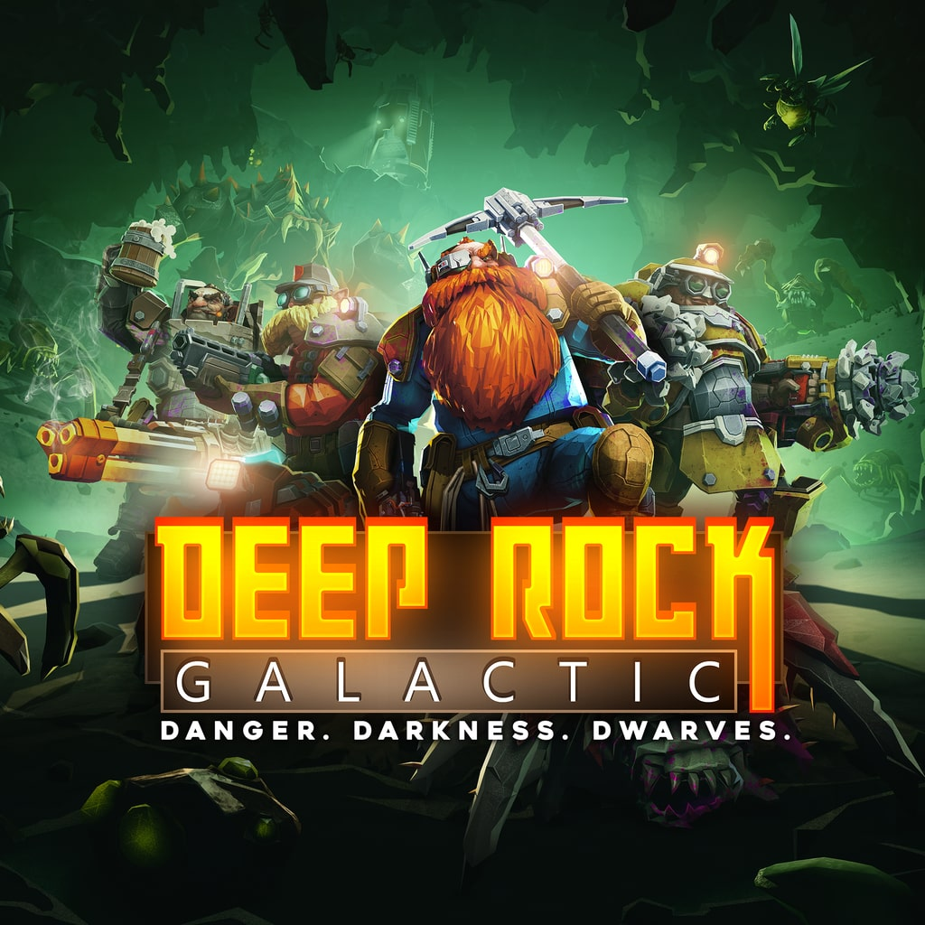

#### Strengths:

* Strong yet flexible core loop.
* Enjoyable and confident game feel.
* Large and welcoming Playerbase.

#### Weakness:

* Core loop is fairly lacking with risk.
* Progression feels too slow and tedious.
* Rewards doesn’t seem to match the amount of work required.

#### Market Position:

Available on Windows, Xbox (one and series x), PS4, and PS5.

Is one of the most well regarded game in the looter shooter genre and has arguable the most dedicated and loyal fanbase in all of the indie game industry.

#### Similarities:

* Similar concept and overall goal.
* Similar metagame loop.

## Design Pillars

* **Greater risk for greater rewards** – Overall game design will focus on encouraging and rewarding the Player for taking greater and greater risks and still succeeding.
* **Cryptic but informative tells and warnings** – Monsters that the Player faces will all have specific sounds and behaviours that Players can learn and utilize over their playtime (though this info is never specifically explained to them).
* **Flight over fight** – The Player is to be never given any tools that allow them to outright stop or kill a threat, the only way for Player to deal with a threat is by outsmarting or outrunning them.
* **Streaks over cashing out** – The Player is incentivised to maintain streaks through level depths and loot run for as long as possible, maintaining these streaks result in far greater rewards then it they were cashed in individually.

# Gameplay Design

## Synopsis of Gameplay

Gameplay is focused around sustaining and risking runs for greater rewards in the long term. Player starts in a camp/town where they can sell off their ore for cash that can then be used to purchase one use items or upgrades to the Player or the elevator. The Player can also use their money to contribute to a quota that must reached within four days or else the Player loses and must restart from the beginning.

The Player then enters the elevator and arrives at the first floor of the mine, here they must explore the level in search of ore while avoiding monsters. The Player can only hold so much ore at a time, the more ore they are carrying, the slower they are which can make escaping from monsters more difficult. The Player can deposit their ore at the elevator at any time, however, the more the Player deposits at once, the greater bulk bonus that deposit gets.

When Player decides to, they can return to the elevator and either cash in their run, return to the surface, and end the day or (if they have collected enough from the current level) go deeper into the mines; going deeper increases the frequency and danger of monsters as well as the amount of ore that the Player can find, it will also add to a bonus that the Player gets if they return to the surface. If the Player dies, they lose their haul and return to the surface the next day with nothing to show for it forcing them to become even riskier in the next run, they also loss any items or Player upgrades that they have purchased.

## Game Loops

### A diagram of a project Description automatically generatedCore Loop

### Town Loop

### Exploration Loop

### Elevator Loop

## Economies:

### A diagram of a diagram Description automatically generated with medium confidenceTown Economy

### Risk Economy

## Mechanics

### Player locomotion – Movement

**Summary** – The Player is able to walk, sprint, and crouch walk in any direction.

**Details:**

* Moving always makes noise for the AI, crouch walking makes very little noise while sprinting makes the most amount of noise.
  + Walking should generate noise at range of 10m.
  + Crouching generates noise at a range of 5m.
  + Sprinting generates noise at a range of 20m.
* Movement speeds would start at around the real life average (1.3 m/s) to give a good basis for balancing.
* By default, sprinting makes the Player move at 3x movement speed (3.9 m/s) while crouching makes the Player move at 0.7x movement speed (0.91 m/s).
* Sprinting drains stamina, upon running out the Player is forced to stop sprinting, stamina regenerates overtime.
  + Stamina starts at a base of 100, decreases by 10 per second while sprinting.
  + Stamina regenerates at a rate of 5 per second after a 5 second delay from sprinting (indicated by heavy breathing).
* Speed decreases as the Player’s bag is filled with ore (down to around half speed aka 0.6 m/s).

**Related mechanics & systems:**

* Player Locomotion – Looking.
* Interact – Mining & Stashing.
* Inventory System.

### Player locomotion – Looking

**Summary** – The Player would be able to look in any direction in a first person perspective.

**Details:**

* By default, game will rotate the camera according to 30% of the mouse’s XY inputs.
  + Y axis is not inverted by default (move mouse down to look down).
  + Value can be changed to any value between 0.01 (1%) and 1.50 (150%).

**Related mechanics & systems:**

* Player locomotion – Walking.

### Interact – General

**Summary** – When looking at an interactable object/item within 2m, the Player can press the mouse 1 to start interacting with it. What occurs depends on the interacted object/item.

**Details:**

* By default, interacting with valid objects will add them directly to the Player’s inventory.

**Related mechanics & systems:**

* Player Locomotion – Movement.
* Player Locomotion – Looking.

### Interact – Mining & Stashing

**Summary** – When looking at an ore vein while having a pickaxe equipped, the Player can hold down mouse 0 to start hitting the vein, dealing damage to its health. Once its health reaches 0, the ore is directly added to the Player’s inventory and the vein is replaced by a regular wall. The Player can then stash any ore in their inventory by interacting with the elevator. Stashed ore is turned into money upon returning to the surface.

**Details:**

* Ore veins have a certain amount of health depending on what ore it is (check economy section for more details).
* Player’s pickaxe deals a base of 20 damage every 1.5 seconds, these values can be upgraded.
* While mining, play a looping animation of the Player swinging their pick towards the ore (doesn’t need to connect), time the animation based on the swing speed of the Player. When the pickaxe is supposed to ‘strike’ the ore in the animation, deal damage and show sparks and small debris coming off the ore.
* Whenever the animation shows the pickaxe hitting the ore, play a noise that can be heard by the AI (amount of noise should have a range of 30m).
* As a vein gets more damaged, a cracked overlay slowly becomes opaquer to show how close the vein is to breaking.
* More valuable ores are generally more durable and shinier.
* The more ore the Player has, the longer it takes to stash and the slower the become.
* When the Player stashes ore, the number of ore gained is increased depending on the size of that load. The more ore the Player stashes at once, the greater the bonus will be. (+2% per ore added)
* If the Player does not have enough space for the ore, it is dropped onto the ground next to the Player.
* Player loses all velocity upon mining or stashing and cannot gain velocity until they either stop or finish mining/stashing.

**Related mechanics & systems:**

* Player locomotion – Movement.
* Player Locomotion – Looking.
* Inventory System.
* Mine System.

### Interact – Use Item

**Summary** - When holding a usable item and not looking at a interactable object/item, the Player can press or hold mouse 0 (depending on the item) to use the held item. Effect depends on the Item type.

**Details:**

* To use an item, the Player must equip the item either through the inventory menu or through the hotbar on the bottom of the screen. This will show the Player character holding out the item in front of them.
* When holding a item, moving will cause the item to move down as if the Player character is bending down to make moving easier. How far down depends on the Player’s current speed.
* For one use items, they drop where the Player is currently standing as soon as the Player presses the button.

**Related mechanics & systems:**

* Player Locomotion – Movement.
* Player Locomotion – Looking.
* Interact – General.
* Inventory System.

### Video Mockup:

This [link](https://youtu.be/q6IBe6brc7o) shows a mockup of the mechanics listed above.

### Interact – Buying & Selling

**Summary** – This involves the Player’s ability to interact with shops to purchase new items or upgrades and sell back old items. This is also used by the Player to contribute to the quota.

**Details:**

* The Player is given a 4-day deadline to contribute enough funds to reach the quota that starts at a random number from $200-300. Failure to reach it by the end of the last day results in the Player’s progress fully resetting and forcing them to start again.
* Fulfilling the quota gives the Player 3 extra days added to the deadline of the next quota and increases the required payment by a random percent between +40%-+80%. This goes on infinitely until the Player eventually fails to fulfill it and restarts from the beginning.
* Contributing to the quota requires the Player to interact with an ATM on the surface and chose how much of their money they wish to contribute.
* To buy items, the Player must enter one of the shop tents on the surface and interact with the shopkeeper.
  + There are three shops based on the different types of purchasable items (see Game Content for more details).
* There are two types of upgrades available for purchase, ‘Miner Upgrades’ and ‘Elevator Upgrades’. Miner Upgrades affect the Player themselves and can lost upon death. Elevator Upgrades affect the elevator rather than the Player and are not lost if the Player dies.
* Items can be sold back for their sell value, upgrades cannot.
* Players can also choose to purchase ingame cash with real money at a rate of $50 ingame per $1 AUD. Players can either buy a specific amount of ingame currency for that rate or purchase one of the currency packs that offer bonus cash for the same price.
* Player can choose to watch an ad to receive a random discount (20%-60%) on all items in that store.

**Related mechanics & systems:**

* Player Locomotion – Movement.
* Inventory System.
* Mine System.

### Heath & Damage

**Summary** – The ability for entities to deal/take damage. Receiving damage reduces the entities health, upon reaching 0, the entity dies.

**Details:**

* Amount of health depends on the entity. Player starts at 100.
* Player health is shown through the amount of blood on the screen.
* The Player can only recover health through either items or by traversing to the next level/to the surface. Traversing to the next level restores 20 health while
* Npcs (Non-Player-Character) that die go limp and have their AI disabled.
* Death causes the Player to suffer the following:
  1. Lose some of their stashed ore (depending on final depth, -4% per level down to a minimum of -80%).
  2. Lose all their items and 1 rank off all their Player upgrades (0 means the Player loses the upgrade outright, cannot go below 0).
  3. Gain payment for remaining ore (without depth bonus).
  4. Forced to return to the surface, ending the day.

**Related mechanics & systems:**

* Mine System.
* Inventory System.
* Interact – Buying & Selling.

## Systems

### Inventory System

**Summary** – The inventory system is how the Player collects and stores items, ores and other collectables. The Player has a limit to amount they can carry, upon passing this amount, the Player is unable to collect any more items until they drop something from their inventory.

**Details:**

* The Player starts with a 40 kg capacity.
* The more the Players inventory is filled, the slower they become. At 100% capacity, the Player is slowed down to 60% of their normal speed (by default, walking would be 0.78 m/s and sprinting would be 2.34 m/s at max capacity).
* Stamina drain from sprinting is to remain unaffected from capacity as their effective value has already been decreased by the aspect of sprinting being slower.
* An icon on the side of the screen shows the Player how close they are to their inventory capacity.
* The Player can press ‘I’ to get a more detailed breakdown of their inventory. They can also choose to drop or equip items in this menu.
* The Player can equip and hold out certain items from their inventory to allow them to be used, this doesn’t decrease its load.
* The Player can drop items from their inventory, dropped items are placed in front or around the Player (wherever space is available), the Player can then pick up the dropped object by looking at it and pressing ‘E’.
* Player’s inventory is lost upon death.

**Related mechanics & systems:**

* Player Locomotion – Movement.
* Interact – Mining & Stashing.
* Interact – Use Item.
* Interact - Buying & Selling

### Mine System

**Summary** – The mine system involves the level layout & ore generation, ore and depth tracking, and monster spawning in the game.

**Details:**

* Upon the Player entering a level, the layout and number of ore in the level is procedurally generated depending on the depth the Player is at . Lower depths result in bigger levels and a greater number of ore.
* Whenever placing ore at a spot, generate a random whole number between 0 to (8 x current depth), then round that number down to the next available ore according to its spawn chance, if no ore is available then do not place any ore.
  + As an example, the random number generated is 15, rounding that down to next ore gives us iron with it’s spawn chance at 12, so place iron.
* When exiting a level, the Player can choose to either go deeper or return to the surface. Returning to the surface resets the depth, ends the day and the Player receiving payment for their stashed ore (which is increased depending on final depth). Going deeper increases the depth and brings the Player to a new level.
* Upon returning to the surface, the Player is given a breakdown of the amount of money they made and are given the option to watch an ad to gain an additional random bonus (+50%-+100%) towards their total gain.
* After some time, monster will start spawning in the level. The frequency, amount, and danger of the monsters depends on the current depth. Lower depths lead to more dangerous levels.
  + After a minute into the level, the system will try to spawn a monster. The method is like ore spawning but the number generation is from 0 to ((5 x current depth) + (2 x minutes spent in the level)). After spawning, the system will try to spawn another monster in 120-(current depth x 2) seconds with a minimum of 40 seconds.
* In relation to this system, death causes the Player to lose some of their stashed ore (depending on final depth), gain payment for remaining ore (without bonus), and ends the day.

**Related mechanics & systems:**

* Interact – Buying & Selling.
* Interact – Mining & Stashing.

### AI System

**Summary** – The AI System involves the general perception system that all AI entities use for different purposes, this includes the senses of sight, hearing, memory, and object priority. This also manages the different states that the AI can be in (Wander, Investigating, and Alerted).

**Details**:

* The system focuses on managing the AI’s perception and it’s effect on the AI’s aggression; based on that aggression, it will then change the AI’s state.
* Sight involves the ability for AI to physically see the target in front of them at certain distance (distance depends on AI). This also considers the lighting on the target (more light means more visible) and whether the target is standing or crouching (crouching makes the Player less visible than standing). If the AI can no longer see the target, it will consider the target as lost and will treat it’s last location as memory.
  + While the AI can see the target, it will gain 10 – 4 (if crouched) – 7 (if in darkness) aggression per 0.2 seconds (cannot go below 0).
* Hearing involves the AI’s ability to hear audio events that are triggered by certain actions. This considers the range for both the noise being triggered and AI’s Hearing. Only when the noise range overlaps the AI’s hearing range does the AI get attracted to the noise.
  + When AI hears a noise, it will gain 60 - 1 (per metre from origin location) aggression (cannot go below 0). Noises from the same location cannot give multiple instances of aggression. This amount is reduced to 25 percent if the AI is currently in the Alerted state.
* Memory handles the AI’s ability to remember the target after spotting or hearing them. When the target gets out of view and stops triggering noises, the AI will use the last location it heard or saw the target as it’s new target.
* While not truly a sense, object priority is mainly focused on managing situation where multiple sense events are triggered (for example the AI hears a noisemaker while also hearing the Player moving). Object priority makes the AI focus on the event who’s source has a higher priority (if the AI hears a noisemaker and a Player, they will go for the noisemaker as that has a higher priority); the only exception would be if the sense itself is a higher priority then other senses (if the AI hears a noisemaker and sees the Player, they will go for the Player as sight has a higher priority).
* The priority for senses goes in following from highest to lowest: Sight, Hearing, Memory. Higher priority senses will also prevent lower priority senses from adding aggression.
  + As an example of the senses: the AI spots the Player and chases them down a corridor, the AI then loses sight of the Player because they ran around a corner but they still hear the Player so they instead switch to their Hearing and chase the noise, the Player then stops making noise so the AI switches to their Memory of where they last heard or saw the Player, the AI then hears a firecracker go off nearby so abandons their Memory of the Player and moves towards the firecracker.
* Some AI may only use certain senses.
* The Wander state is the default state for all AI, they stay in it as long as the AI is not in a higher priority state; by default, this state causes the AI to pick a random spot to according to the navmesh, they will then start moving towards it. Once arrived they will then pick a new location and start the process again.
* The Investigating state is triggered when the AI’s perception system gets triggered when they’re aggression is greater than 0 but not enough to pass their max aggression. By default, this state causes the AI to focuses on its last target (usually a location) and either moves towards or around that target if they’re already at the location.
  + After 5 seconds in this state, the AI will start losing 10 aggression per second (unless sight or hearing gets triggered) to simulate the AI losing interest in the target. If aggression goes back to 0, return to Wander state.
* The Alerted state is triggered when the AI’s aggression has passed its max aggression. By default, this state causes the AI to start chasing after the target. When the AI gets within attacking range of the Player (depends on entity), they will attempt to attack the Player, this triggers an animation where, at a certain point, they will deal damage to the target if they are still in range (animation and damage depends on the entity).
  + If the AI cannot see or hear the target, they will start losing 5 aggression per second to simulate the AI losing interest in the target. If aggression goes below the AI’s max aggression, it will switch over to the investigating state.
* States also have priority to make the AI focuses on what’s more important at that point in time. For highest to lowest it goes: Alerted, Investigating, Wander.
  + As an example of the states: AI spawns in the Wander state and starts moving towards the other side of the level. They then hear the Player mining and abandons the Wander state for the Investigating state and investigates the noise. They then spot the Player for long enough to switch over to the Alerted state abandoning the Investigating state. They then chase the Player through the mine, during the chase they hear a firecracker go off which would’ve switched them to the Investigating state but their current state (Alerted) is higher priority, so they ignore it. After a while, they the last spot they saw the Player and can no longer hear or see them so switches over to the Investigating state and searches around their current area for the Player. After some time, they can’t find the Player so return to the Wander state.
* When switching states, have the AI play a form of bark to let the Player know what the AI is currently doing and give them a chance to plan out their approach.

**Related mechanics & systems:**

* Player Locomotion – Movement.
* Interact – Mining & Stashing.
* Health & Damage.

# User Interface & Controls

## Play HUD

### Description:

The interface for normal play (Player is wondering in the camp or mine), contains a stopwatch and depth indicator on the top of the screen, an inventory indicator on the right side of the screen, an equipped item indicator on the bottom left of the screen, a hot-swap bar at the bottom of the screen, and a Health indicator around the edge of the screen.

### Sub-elements:

* Stopwatch.
  + Only visible when in the mine, starts ticking up as soon as the Player first leaves the elevator and resets when they transition to a new floor.
* Depth indicator.
  + Only visible when in the mine, shows how far down the Player currently is.
* Inventory indicator.
  + A bag icon on right side of the screen that gets filled depending on how full the Player’s inventory is. Also has a key icon next to it to indicate what button to press to get a more detailed list of the Player’s inventory.
* Equipped item indicator.
  + An icon on the bottom left of the screen that shows a sideview of the item that the Player currently has equipped. If the item has limited uses, a bar appears next to it showing the amount of charge it has left.
* Hot-swap bar.
  + A set of icons on the bottom of the screen showing the first ten usable items in the Player’s inventory and what key they can press to access it (only number keys starting from 1 and ending at 0).
* Health indicator.
  + As the Player loses health, blood splatter slowly appears around the edge of their screen.

### Feedback Systems:

* Heath indicator.

Shows how much health the Player has lost.

* Equipped item indicator.

Shows what item the Player has equipped and how many uses it has left.

* Inventory indicator.

Shows how much space the Player has left in their inventory.

* Stopwatch.

Shows the Player how long they have been in the current level in real minutes and seconds.

* Depth indicator.

Reminds the Player how far down they have gotten in this run.

* Hot-swap bar.

Shows the first ten usable items in the Player’s inventory and what key they can press to quickly switch to it.

### Mockup:

## Inventory HUD

### Description:

The interface for when the Player inspects their inventory. It will be a categorized list of the Player current inventory that shows the items name, quantity, weight and value, the bottom of the list will show how much leftover space there is; The list will cover the centre of the screen. On the bottom of the screen will be button icons with text saying what it will do.

### Sub-Elements:

* Inventory
  + A box that lists every item in the Player’s inventory categorized in different scroll boxes, also shows how much space the Player has left.

### Feedback Systems:

* Inventory

A visual list of what the Player has on their person and how much more they can carry.

### Mockup:

## Store HUD

### Description:

The interface for when the Player buying items or upgrades from a store. It will be a list that shows the price, and description of the item, and how many the Player already has (or for upgrades, what tier the Player is currently at and if that’s the max). The Player’s current amount of money and inventory space is also displayed at the bottom of the window. Next to the money counter is a shop button that brings the Player to the shop where they can purchase more ingame money. Next to the exit button is an option to watch an ad for a random discount (20%-60%).

### Feedback Systems:

* Item list.

Shows how many times the Player has purchased the item.

* Money counter.

Actively shows how much money the Player currently has.

* Weight counter.

Actively shows how much space the Player has left in their inventory.

### Sub-Elements:

* Item list.
  + Shows each item available in the shop along with information of each item and an option to purchase it.
* Money counter.
  + A counter for money the Player currently has.
* Store button.
  + A button to visit the in game store to purchase more ingame money with real cash.
* Weight counter.
  + A counter for the space left in the Player’s inventory.
* Ad button.
  + A button to watch a full screen ad for a random global discount on all items in that store.

### Mockup:

## Game Over HUD

### Description:

A HUD that shows after Player dies. Covers the screen in red and tells the Player that they have died and how many items and upgrades they lost. There will also two buttons to Return to the Surface and Return to Main Menu; if the Player leaves for the main menu then continues the game, they will respawn back at the surface as if they have chosen the other option.

### Sub-Elements:

* Return to the Surface button.
  + Returns the Player to the surface and ends the day.
* Return to Main Menu button.
  + Brings the Player back to the Main Menu. Still treats it as the Return to the Surface button when the Player continues.
* Lost Summary.
  + The amount of cash that the Player lost from lost items and upgrades.
* Ad space.
  + A moderate banner below the menu buttons that shows off a banner ad.

### Feedback Systems:

* Lost Summary

Shows how much stuff the Player had in their inventory.

### Mockup:

## Run Breakdown HUD

### Description

Shows after the Player successfully returns to the surface after a run. Acts as a breakdown of what the Player has collected, what bonuses they have gained and how much money they were able to sell it for. Also has an option to watch an ad for an additional bonus to their loot. When it first opens, show an animation of the different bonus and items the Player has gotten (similar to the intermission screen in Doom 1993 as seen in the first 16 seconds of this [video](http://www.youtube.com/watch?v=aC-IrkYDr_I&t)); if the Player clicks anywhere other than the continue button, skip to the end of the animation.

### Sub-Elements:

* Breakdown list.
  + Lists the items the Player has gotten; the bonus they gained from depth and how much money they were able to sell their haul for.
* Continue button.
  + Removes the HUD and puts the Player back in control of their character.
* Current Money Counter.
  + Shows next to the continue button, shows how much total money the Player now has (only shows at the end of the intro animation).
* Ad button.
  + Appears next to the gained money in the breakdown list, allows the Player to watch one ad to gain a random additional bonus to their total profit(between +50%-+100%).

### Feedback Systems:

* Breakdown list.

Shows everything that the Player has collected in the run as well as depth bonus they were rewarded for how deep they went into the mine.

* Current Money Counter.

A counter that constantly keeps track of the Player’s money.

### Mockup:

## Controls

|  |  |
| --- | --- |
| Input | Action |
| WASD | Moves the character. |
| Shift | Enables sprinting when the Player is moving forward (and stamina is available). If Player is currently crouched, make them stand. |
| C | Toggle crouch, ignored if sprinting. |
| L Ctrl (Hold) | Crouch, ignored if sprinting, stands up when let go. |
| Mouse XY | Rotates the pitch and yaw of the camera. |
| Mouse 0 | Use held item. |
| Mouse 1 | Interact/Put away held item. |
| I | Toggle inventory. |
| 1-0 (excluding num keys) | Equip item from hotbar. |

# Art Style & Design.

## Environments:

### Mine:

The mine is to look dark and decrepit to amplify the feeling of loneliness and fear of the unknown. Areas are to look identical to give off a feeling of being lost and running in circles. Lighting should be minimal and to reduce the amount of information given to a Player who hasn’t brought their own source of light.

### Surface:

Surface should feel welcoming compared to the mines. Area should always be in the day and fully lit up. Tent and campfires should be the only structures in view besides the mine. Surrounding area should be a infinite desert to make the Player feel isolated.

## Characters:

### Humans/Player:

Humans (such as the Player) should be fully clothed in rugged and scrappy looking hazmat gear. Heads should be covered with a gasmask that obscures all facial features to dehumanise the humans that the Player comes across.

### Monsters:

There should be two types of visual designs for monsters, either biological or mechanical.

#### Biological:

Biological monsters should be based on different on monsters in folklore (especially eastern European folklore) and internet horror stories. Focus of abnormal physical proportions and characteristics to create the look of creature that shouldn’t exist. For aggressive monsters (ones that mainly just search and chase the Player), focus on a more animalistic body structure; for more passive monsters (ones that act smarter or aren’t always looking/chasing the Player), focus on a more human body structure that has been distorted for one reason or another, Players should be able to look at these monsters and tell that they were human at some point. Here are some examples of biological monsters:

Aggressive:

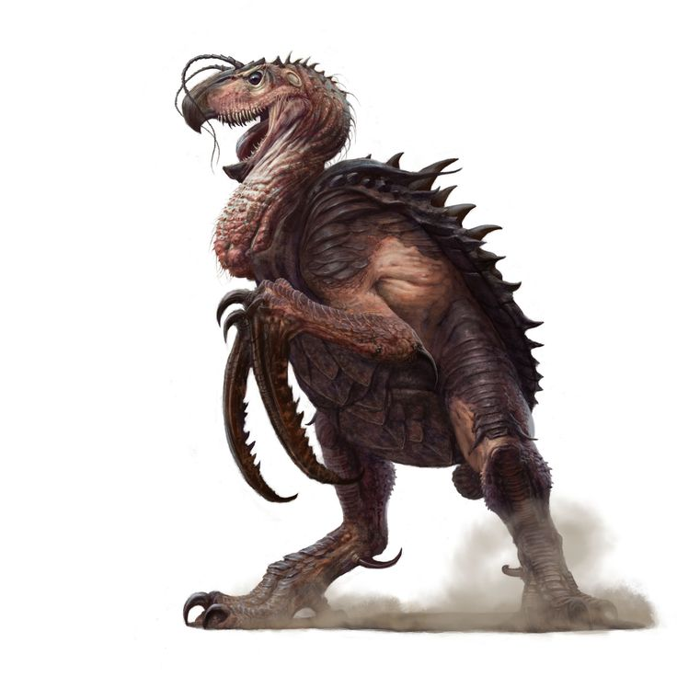DND’s Hook Horror: Witcher’s Fiend:

Passive:

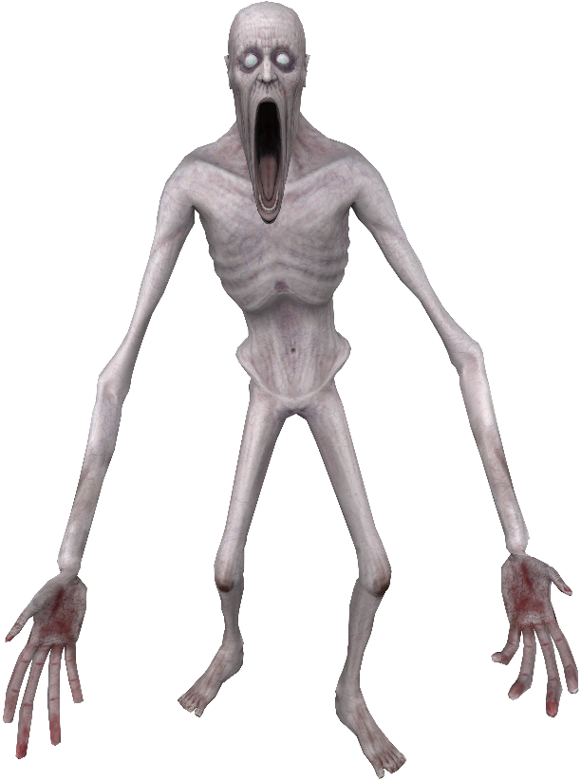Amnesia’s Beast: SCP’s SCP-096:

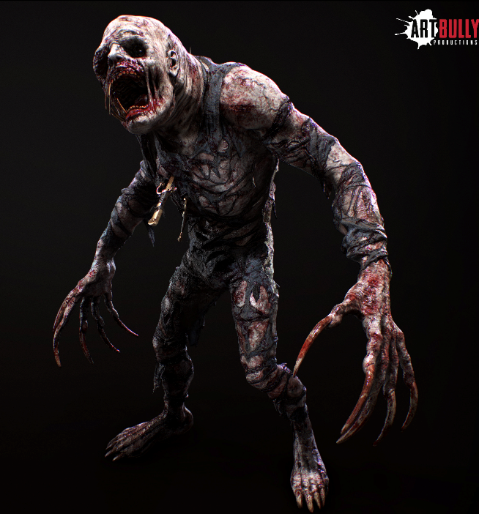

#### Mechanical:

Mechanical monsters are different kinds of machines and contraptions that eroded over time in the mines. Focus on tech that could reasonably be made in the modern day or the very near future. Make it look like it was made in a scrappy manner or in a post-apocalyptic setting. Here are some examples:

Lethal Company’s Turret: Fallout New Vegas’s frag mine:

## SFX:

Audio should mimic real life whenever possible, this goes for what the sound is and how it behaves. Attenuation should also be as accurate as possible to reward Players who utilise their hearing by giving more info and feedback of their actions and their surroundings. Sounds occurring in the mines should contain a decent amount of echo and reverberation to help enhance the atmosphere and improve immersion.

## Music:

The music in ‘Into The Depths’ should mainly be orchestral with possibly some electronic elements. For examples, see the soundtracks for [Amnesia: The Bunker](https://open.spotify.com/album/5PhifTUHR8559o4dm3U8h3?si=3qabnG4XS4e29FrEmvAqrg) and [SOMA](https://open.spotify.com/album/19nBFW5TDocB8rQTBHO9Qc?si=7wp5Gr49QCOKxHYjatyGAQ)

### Mine:

Music in the mines should be intense and suspenseful. It should also build up or calm down depending on the Player’s situation. In general, they can split in the following categories:

* Safe.

When the Player is not being actively chased by any monsters, the music’s should have a slow tempo and low intensity, it should also involve minimal instruments to not distract the Player from other more important sounds and maintain immersion. Examples include the following:

* + [‘Officer Hub’](https://open.spotify.com/track/2LOHGQ8Rd19mP3diPb0hEx?si=ab8319fa48c242d5) from Amnesia: The Bunker.
  + [‘The Freakshow’](https://open.spotify.com/track/39Mri4oiWSu0uUCXbvhZLH?si=f47bb27b02944d84) (0:00-0:40) from Days Gone.
  + [‘Soldier Quarters’](https://open.spotify.com/track/2yQG4AVZLJx7xMIoaoBMmw?si=4d3f705c619240f7) from Amnesia: The Bunker.
* Searching.

When a monster is actively searching for the Player, the music’s intensity should increase but maintain a similar tempo to the Safe tracks to create a sense of approaching danger. Examples include the following:

* + [‘The Freakshow’](https://open.spotify.com/track/39Mri4oiWSu0uUCXbvhZLH?si=f47bb27b02944d84) (1:10-2:00) from Days Gone.
  + [‘Hunted’](https://open.spotify.com/track/7gz74FwkHahX1lo87sO45f?si=c9a5a02d964f44a6) (0:30-0:50) from Amnesia: The Bunker.
  + [‘Shotgunner’](https://open.spotify.com/track/41uA01WjxQm18BecaA03dx?si=37439ff08de84d6a) (starting 0:37) from Amnesia: The Bunker.
  + [‘Infected Is Near I’](https://open.spotify.com/track/3KXEwh2Ts77FYzmyUOJMmS?si=944bb1e5063144c1) from Penumbra.
* Chasing.

When a monster is actively chasing/attacking the Player, the music’s intensity should be at it’s peak in this situation and tempo should gradually increase as the Player stays in this state; all to let the Player know how much danger they’re in and that they need to act. Examples include the following:

* + [‘The Freakshow’](https://open.spotify.com/track/39Mri4oiWSu0uUCXbvhZLH?si=f47bb27b02944d84) (2:10-3:00) from Days Gone.
  + [‘Hunted’](https://open.spotify.com/track/7gz74FwkHahX1lo87sO45f?si=c9a5a02d964f44a6) (starting 0:50) from Amnesia: The Bunker.
  + [‘Suitor Attacks’](https://open.spotify.com/track/7uRgAqTJlCowac3LvCwXgW?si=188e823569ae4f41) from Amnesia: The Dark Descent.

Switching music should have a slight delay (2-4 seconds depending on what fits for the track) to make sure that the music can’t be exploited by the Player to tell how much they are in danger until it’s too late. If the multiple conditions for the music are being met then use a priority system like the AI (Chasing being highest priority followed by Searching then Safe), if both Chasing music and Searching music is meant to be played then only play Chasing.

### Surface:

Music on the surface should feel uneasy when first heard but feel safe once compared to the music from the mines. Make Player feel like they can rest but is not completely safe. Some examples include:

* [‘Officer Hub Safe Theme’](https://open.spotify.com/track/41tffb5SQ74VZevsSGHXop?si=d67c9398c47f4b02) from Amnesia: The Bunker.

# Game Content:

## Ore:

|  |  |  |  |  |
| --- | --- | --- | --- | --- |
| Ore | Weight | Vein health | Value | Spawn Chance |
| Coal | 1 | 40 | $5 | 3 |
| Iron | 3 | 70 | $8 | 8 |
| Nickel | 4 | 85 | $14 | 25 |
| Tin | 3 | 80 | $12 | 32 |
| Copper | 4 | 100 | $18 | 42 |
| Silver | 7 | 120 | $35 | 65 |
| Gold | 9 | 220 | $40 | 79 |
| Platinum | 12 | 260 | $52 | 81 |
| Titanium | 16 | 380 | $85 | 95 |
| Emerald | 3 | 400 | $150 | 140 |
| Diamond | 5 | 500 | $200 | 160 |

## Store Items:

NOTE: Money, weight, and item quantities is to always be treated as a integer (whole number), all rounding should always round down unless specified otherwise.

### General Store (Usable Items):

|  |  |  |  |  |
| --- | --- | --- | --- | --- |
| Name | Weight | No. of Uses | Value (Purchase, sell) | Feature |
| Flashlight | 5 | 100 units of power. Resets upon changing floors. | $80, $40. | Lights up area infront of Player while equipped. (uses 1 power per second) |
| Flashbang | 2 | 1 use | $90, $45. | Drops on use, explodes after 3 seconds, explosion stuns all non-mechanical monsters within 30m for 3 seconds and blinds them for a further 6 seconds (they can no longer use their sight and must rely on their hearing to track the Player if they have any). They can also blind and deafen the Player for 5 seconds if they are looking at the explosion. |
| Flare | 4 | 1 use | $20, $10. | Drops on use, emits strong light (and moderate noise) for 90 seconds before cutting out. |
| Glowstick | 1 | 1 use | $12, $4. | Drops on use, emits dim light that fizzles out over 120 seconds. |
| Noisemaker | 8 | 1 use | $40, $20. | Drops on use, starts making loud noises after 5 seconds that last for 30 seconds. |
| Firecracker | 4 | 1 use | $15, $3. | Drops on use, makes a loud noise after 3 seconds. |
| First Aid Kit | 10 | 200 units of health. Never recovers. | $100, $60 (decreases by $3 per unit used) | Player heals themselves to full after going through a 3 second animation (they cannot sprint during this). If there aren’t enough units left in the kit for a full heal, Player will heal for the remaining units left in the kit. |
| Adrenaline Shot | 3 | 1 use | $130, $40 | After a 1 second animation, Player gains 75 hp and multiplies their movement speed by 1.5 for 30 seconds. Gained health decays over time (cannot go below 1). |

## Mining Store (Mining tools and upgrades):

|  |  |  |  |  |
| --- | --- | --- | --- | --- |
| Name | Value (Purchase, sell) | Tiers (cost per tier) | Weight | Effect |
| Pickaxe Lv1 | $20, $5 | N/A | 4 | The starting pickaxe, deals 20 damage per strike. |
| Pickaxe Lv2 | $60, $20 | N/A | 10 | An upgraded pickaxe, deals 30 damage per strike. |
| Pickaxe Lv3 | $140, $40 | N/A | 15 | A further improved pickaxe, deals 40 damage per strike. |
| Pickaxe Lv4 | $200, $100 | N/A | 25 | A near perfect pickaxe, deals 50 damage per strike |
| Swift Hands | $150, not sellable. | 4 (+40%) | N/A | Makes you swing 15% faster per tier when mining. |
| Packer | $100, not sellable. | 5 (+100%) | N/A | Increases your carrying capacity by 40% per tier. |
| Athletic boots | $50, $20. | N/A | 5 | Always on as long as in inventory, prevents other boots from being purchasable. Doubles max stamina and max sprint speed by 40% but decreases walk and crouch speed by 30% |
| Hiking boots | $40, $10. | N/A | 7 | Always on as long as in inventory, prevents other boots from being purchasable. Increases walk speed by 40% but also increases stamina drain by 50% and decreases sprint speed by 25%. |
| Thin boots | $60, $15. | N/A | 3 | Always on as long as in inventory, prevents other boots from being purchasable. Increases crouch speed by 20% and decreases all noise from movement by 40% but decrease stamina regen by 20% and increase all damage taken by 50%. |

## Mechanic (Elevator upgrades):

|  |  |  |  |
| --- | --- | --- | --- |
| Name | Costs | Tiers (cost per tier) | Effect |
| Head Start | 150 | 5 (+20%) | You now have the option to pay and start at lower levels ($30 per level), each tier purchased grants an additional level. |
| Ore Enhancer | 400 | 4 (+50%) | Ores stashed in the elevator will have their value increased by +25%. |
| Odds’o’Death meter | 120 | 1 | A meter in the Elevator that gets more filled based on the amount of monsters currently present in the level. Peaks out at 6 monsters. |
| Mapper | 250 | 1 | Draws a map of the level as the Player explores it. |
| Fixer Upper | 100 | 3 (+100%) | Increase the amount of health the Player restores when going deeper by +20% of their current health |

## Monsters:

Template (Monster Name):

HP: Amount of health the monster has before it dies, or if they have health at all.

Description: a short description of the monster.

Attacks: What the monster attacks if spotted, Player not included as monsters will attack the Player by default, also includes any exceptions.

Vision distance and radius: How far the monster can see in front of them (in metres) and how big is their vision cone (in degrees).

Hearing radius: How far the monster can hear around them (in metres).

Max aggression: Determines how long the monster needs to see/hear the Player to become alerted.

Speed: How fast the monster moves in m/s in each state (shown as Wander, Investigation, Alerted).

Spawn chance: How likely the monster is to spawn. (higher means less likely)

Wander behaviour: What the monster does when in wander state.

Investigation behaviour: What the monster does when in the investigating state.

Alerted behaviour: What the monsters does when in alerted state.

Additional behaviour: Any unique behaviour for the monster (not always needed).

Barks: Sounds that the monster makes and when it makes it.

Appearance Reference: Image references for what the monster should look like.

Sentry:

HP: Cannot be killed.

Description: A stationary unmanned sentry gun, it is the most common of the monsters in the mines, fires fast moving bullets at anything that comes into view. Monsters shot from it will try to run away from it if possible.

Attacks: All monsters (excluding itself).

Vision distance: 200 m @ 45˚

Hearing radius: 0 m

Max aggression: 80

Speed: Always 0 m/s.

Spawn chance: 4 + (1 x current depth).

Wander behaviour: Picks a random yaw rotation to gradually rotate to every 10-15 (randomised) seconds. Rotates at a speed of 40 degrees per second.

Investigating behaviour: Faces the last known location of target as best as it can until it either transitions to either Wander or Alerted. Rotates at a speed of 80 degrees per second.

Alerted behaviour: Turns towards last known location of target and attempts to start shooting it with fast projectile-based bullets that deal 15 damage each that travel at a speed of 300 m/s. The sentry fires 1 bullet every 0.6 seconds and rotates at a speed of 100 degrees per second. The Sentry can fire bullets as long as the target is within its vision distance.

Barks:

Single short beep – Plays while the turret is in it’s Wander state and has reached the random rotation it generated.

Single long beep – Plays when the sentry sees something that causes it to transition to the investigating state.

Two short beeps – Plays when the sentry has switched over to the alerted state and is about to start firing.

Appearance Reference:

A decently sized firearm that is being held up by a spinner on three legs. Like the turret in Lethal Company.

The Horned Bird:

HP: 300

Description: A large anthropomorphic featherless bird that has claws instead of wings and massive horns protruding from the head. Only searches for the Player but will attack any other Horned Birds they come across. Upon spotting an someone to attack, they will chase and swipe at it until it’s either dead or it gets away.

Attacks: Other Horned Birds.

Vision distance: 120 m @ 90˚

Hearing radius: 60 m

Max aggression: 60

Speed: 0.8 m/s, 1.5 m/s, 3.2 m/s

Spawn Chance: 8 + (3 x current depth).

Wander Behaviour: Picks a random spot on the navmesh and moves towards it.

Investigating Behaviour: moves towards target location then moves to random spots around it within 50m, repeats until it has either returned to Wander to transitioned to Alerted.

Alerted Behaviour: Moves directly to target, when within 5m from the target, it will play an animation to attack the target, if the target remains in that range by the end of the animation (1 seconds) they will take 45 damage. After the animation, the Horned Bird will need to wait 2 seconds before being able to attack again. If the target was the Player and Horned Bird kills them, then play an animation of the Bird pinning the Player and biting their head before transitioning to the Game Over HUD.

Barks:

Distorted Pied Currawong call – Plays when returning to Wander state. Also plays periodically at random times while Wander state.

Constant Cassowary growl (see the beginning of this [video](https://www.youtube.com/watch?v=iy-9Z2KrjsY)) – Constantly plays while in investigating state, starts loud to alert the Player before quieting down to a more reasonable level.

Deep distorted bird screeches (mainly from the Channel-billed Cuckoo and the Black-Cockatoo) – Periodically plays while in Alerted state (especially at the start), first screech is much louder compared to the later ones to signify a change in behaviour, will play more often the closer they are to the target.

Deep Sulphur-crested Cockatoo screech – Plays when the Horned Bird is starting it’s attack animation.

Appearance Reference: A large anthropomorphic bird (around 6m tall) with no feathers and tar/coal coloured skin. The Phalanges of the wings are replaced with large claws. Large horns protrude form the two sides of the head that extend down towards the end of the beak.

Overall appearance: Horn design:

Stalker:

HP: 150

Description: A slender, pale, naked male human (no modelled bits, just a featureless body) with large clawlike fingers and a large gapping mouth. Wanders aimlessly around the mines with no real goal until it spots the Player, upon spotting them, it will follow and stalk the Player as they progress through the mine. It will eventually try approaching the Player; once alerted, it will endlessly chase the Player and killing instantly upon getting close enough. The Stalker can be scared away by either staring at it or having another creature attack it at least once.

Attacks: no other monsters.

Vision distance 250m @ 60˚

Hearing radius: 0m

Max aggression: 50

Speed: 1.0 m/s, 0.8 m/s, 2.5-15 m/s, 6 m/s (when scared off)

Spawn Chance: 8 +(6 x current depth). Note: only one stalker can appear per level.

Wander Behaviour: Picks a random spot on the navmesh and moves towards it. As soon as it spots the Player (even for a frame, no matter the condition), it will transition to the Investigating state.

Investigating Behaviour: Slowly follows the Player through the mine, attempts to get closer when the Player stops or slows down. The closer the Stalker is to the Player, the more they will generate aggression (though only when it’s in eyesight of the Player). From 25+m, the Stalker gains no aggression; within 13-24 m, the Stalker gains 2 aggression per second; within 9-12 m, the Stalker gains 5 aggression per second; when less then 8 m from the Player, the Stalker gains 10 aggression per second. This stops when the Player is looking at the Stalker.

Alerted Behaviour: Upon switching over, it will start endlessly chasing the Player, staring no effects it. It will start moving at 2.5 m/s but will slowly accelerate up to 15 m/s. Upon getting within 3 metres of the Player, it will immediately trigger a death animation of it pinning the Player to ground and proceeding to claw out their chest before transitioning to the game over HUD midway through it. If the Stalker ever gets damaged while in Alerted, it will immediately spook it out of Alerted and cause it to run away.

Additional Behaviour: The Stalker will never lose aggression naturally, the only way for it lose aggression is by the Player staring at it (causing it to lose 8 aggression per second as long as the Player has a unintrusive view of the Stalker) and by taking damage from any source (immediately sets aggression to 0). This also causes the Stalker to get spooked and run away from the Player for at least 15 seconds, additional spooks will cause the timer to reset. After running away, the Stalker will then return it’s Wander state.

Barks:

Faint distorted moaning & hiccupping (as if it was holding in excitement or laughter) – Starts playing when the Stalker spots the Player and enters the Investigating state.

Distorted crying – Plays while the Stalker runs away from the Player. (Only plays when the Stalker got within 12m from the Player.

Bloodcurdling scream – Plays while the Stalker is in it Alerted state and is chasing the Player.

Appearance Reference:

An extremely tall (4 m) slender naked man (no bodily features besides bone poking through the skin from malnutrition) with pale white screen, no hair, and large elongated hands and fingers. The fingers are missing their skin and only have a small amount of flesh with sharp and long bones being the only thing left. The mouth is permanently left agape, and their jaw has been stretched down to the breasts. Their eyes are fully white but become bloodshot when they are Alerted.

